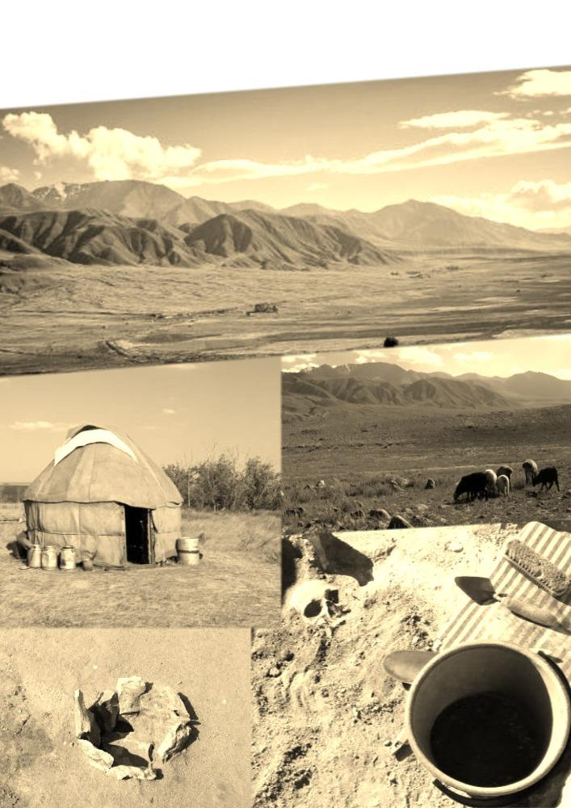
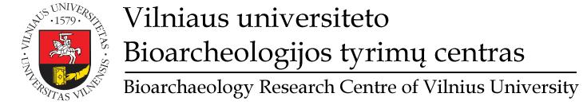
January 13-14, 2019

Vilnius University
Faculty of History, auditorium 211
SEMINAR AGENDA
INTERNATIONAL SEMINAR
on
ARCHAEOLOGY of CENTRAL ASIA

Scientific Programme

January 13th

14:00 - 14:20 | Welcome and introduction  (Dr Giedre Motuzaite Matuzeviciute – Vilnius University, Lithuania)
14:20 - 14:40 | Focus on Central Asia - New International Archaeological Initiatives  (Dr Dmitriy Voyakin – International Institute for Central Asian Studies, Samarkand, Uzbekistan)
14:40 – 15:00 | New data on the Neolithization of South Uzbekistan  (Prof. Yoshihiro Nishiaki – The University Museum, the University of Tokyo, Japan)
15:00 – 15:20 | Genetic evidence for the expansion of millet across Central Asia  (Dr Harriet Hunt – McDonald Institute for Archaeological Research, Cambridge, UK)
15:20 – 16:00 | Coffee Break
16:00 – 16:20 | Review of new excavations at the Chap site in Kyrgyzstan  (Dr Giedre Motuzaite-Matuzeviciute – Vilnius University, Lithuania)
16:20 – 16:40 | Water from the Sky: Comparing the irrigation systems of ancient Central Asia through UAV mapping  (Dr Lynne M. Rouse – German Archaeological Institute, Berlin, Germany)
16:40 – 17:00 | Ceramic traditions in mountainous areas: new research on Bronze and Iron Age pottery from Kyrgyzstan  (Dr Elise Luneau – German Archaeological Institute, Berlin, Germany)
17:00 – 17:20 | Bronze Age archaeological sites in Kyrgyzstan: problems of the research (in Russian)  prof. Kubatbek S. Tabaldiev – Kyrgyz-Turkish University “Manas”, Bishkek, Kyrgyzstan
17:20 – 17:40 | Preliminary results of zooarchaeological analysis at Chap, Kyrgyzstan  (PhD Elina Ananyevskaya – Vilnius University, Lithuania)
17.40-19.00 | Discussion
19.00 | Conference dinner

January 14th
09:00 - 09:20 | Early pastoralism and farming in the Tien Shan and Fergana in the Bronze Age: recent excavations  (Dr Shogo Kume – Tokyo University of the Arts, Japan)
09:20 - 09:40 | Using geometric morphometrics to evaluate multi-scalar Bronze Age pastoral connectivity  (Dr Ashleigh Haruda - Martin Luther University Halle-Wittenberg, Germany)
09:40 - 10:00 | Exploring Early Equine Dairying through Shotgun Proteomics of Human Dental Calculus  (PhD Shevan Wilkin – Max Planck Institute for the Science of Human History, Jena, Germany)
10:00 - 10:20 | Reconstructing prehistoric dairy cultures: tracking the spread of dairying on the Eurasian steppe  (Prof. Dr Christina Warriner – Max Planck Institute for the Science of Human History, Jena, Germany)
10:20 – 10:40 | Pastoralists lost: thoughts on the archaeology of pre-Sintashta pastoralism in the Eneolithic and Early Bronze of Northern Kazakhstan  (Prof. Dr Alan K. Outram – University of Exeter, UK)
11:00 – 11:30 | Coffee Break
11:30 - 11:50 | What lipid residue analysis can tell us about the past?  (Dr Ester Oras – University of Tartu, Estonia)
11:50 – 12:10 | Lipid biomarker detection for tracing millet consumption throughout Eurasia: preliminary results  (Dr Shinya Shoda –Nara National Research Institute for Cultural Properties, Japan)
12:10 – 12:30 | Compound-specific isotopic analysis of archaeological bones to reveal prehistoric food exploitations  (PhD Yu Itahashi – The University Museum, the University of Tokyo, Japan)
12:30 – 12:50 | From tangible grains to intangible ideas: the consequences of food globalization in prehistory  (Dr Xiniy Liu – Laboratory for the Analysis of Early Food-Webs (LAEF),  Washington University, St. Louise, USA)
13:00 - 14:00 | Lunch
14:00 - 14:20 | Living at the Iron Gates: New research on the settlement pattern in the Bactria - Sogdiana borderlands  (Dr Stančo, Ladislav – Institute of Classical Archaeology Charles University, Prague, Czech Republic)
14:20 – 14:40 | Kurgans of Yaz I culture in the Pashkhurt valley, Southern Uzbekistan  (Mgr Jakub Havlik – Institute of Classical Archaeology,  Charles University, Prague, Czech Republic)
14:40 – 15:00 | Highland Urbanism and the formation of Nomadic Power in Medieval Central Asia  (Prof. Dr Michael Frachetti – Washington University, St. Louise, USA)
15:00 – 15:30 | Coffee Break
15:30 – 15:50 | Livestock foddering reveals the origins of millet agriculture on the Eurasian steppes  (Dr Taylor Hermes – Christian-Albrechts-Universitat zu Kiel, Institute of Prehistoric and Protohistoric Archaeology, Germany)
15:50 - 16:10 | Domestication and Dispersal of Arboreal Crops along the Silk Road  (Dr Robert Spengler – Max Planck Institute for the Science of Human History, Jena, Germany)
16:10 - 16:30 | Re-evaluation of plant impressions in pottery from the territories to the north and west of the Black Sea  (Dr Eiko Endo – The Center for Obsidian and Lithic Studies, Meiji University, Japan)
16.30-18.30 | Discussion
18.30 | Conference dinner

Attending as a listener:
Prof. Dr Paula Doumani Dupuy – School of Humanities and Social Sciences,
Nazarbayev University, Astana, Kazakhstan
Prof. Dr Cheryl Makarewicz – Christian-Albrechts-Universitat zu Kiel, Institute of Prehistoric and Protohistoric Archaeology, Germany

Contact details:
Elina Ananyevskaya - elina_ananyevskaya@hotmail.com
Mindaugas Grikpedis - mindaugas.grikpedis@gmail.com
Giedre Motuzaite Matuzeviciute - giedre.motuzaite@gmail.com; +370 61927925

